**PROGRAM ONE CSC 1300-001/002**

**Trivia Night**



[This Photo](http://nlife.ca/audio/andrew-fountain-bible-truth) by Unknown Author is licensed under [CC BY-SA](https://creativecommons.org/licenses/by-sa/3.0/)

**Assigned:** Friday, August 30th, 2019

**Due:** Thursday, September 12, 2019

**Overview:**

In this assignment you are going to create a trivia game based on a topic of your choice. At the end you will tell the users their score and print out a well formatted comment based on their performance.

**Important Rules to Remember:**

* You do NOT work with a partner, friend, or classmate on this program!! This will be considered cheating and you will earn a ZERO for this programming assignment. Get help from tutors & me when you get stuck!!
* You are to write ten ORIGINAL questions – do NOT copy my questions.
* Include comments throughout your code
* Make your output neat & easy to read

**Specifications:**

**Basic Flow of the Program –**

1. Your source file must contain a comment block at the top of your code containing the title of your program, the author of the program (you), the date you started the program, and the purpose of the program.
2. When the user runs the program, you should print a horizontal line of dashes, then the title of the program “Welcome to YourName’s Topic Trivia Game”, and on the next line should be another horizontal line of dashes.
3. Then, the program should describe to the user what they will be doing for this program.

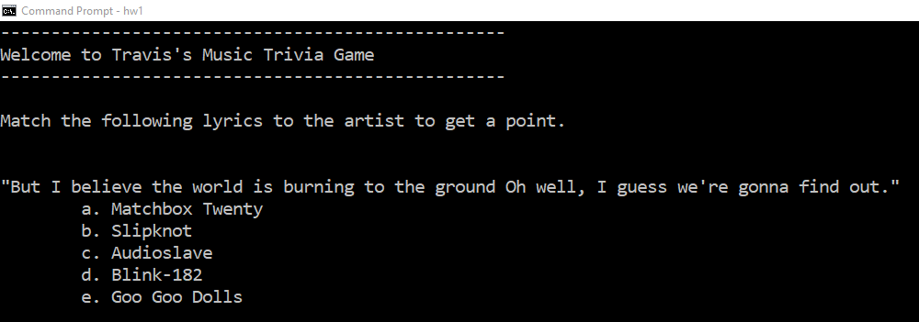

1. Then, your program will ask each of the ten questions. Each question should have between three to five possible answers – allowing the user to select one of them. You may assume anything that isn’t the correct answer is wrong meaning you do not have to validate input.
2. Then, your program will print the results of the test. Telling the user their score and printing a message that varies depending on that score. If they have a perfect score you should tell them so. If they get between 5 (inclusive) and 10 the message should congratulate them. If the user scores less than five you should post a message telling them to try again or something similar.
3. Last, your program will ask the user if they want to run the program again. If they do, then you should start the game again.

**How to tally results –**

1. You should have a variable to store the score that starts at zero each time the game is ran.
2. Each correct value should add 1 to the points. Wrong answers should receive a message explain that the answer is incorrect.

**SAMPLE OUTPUT**

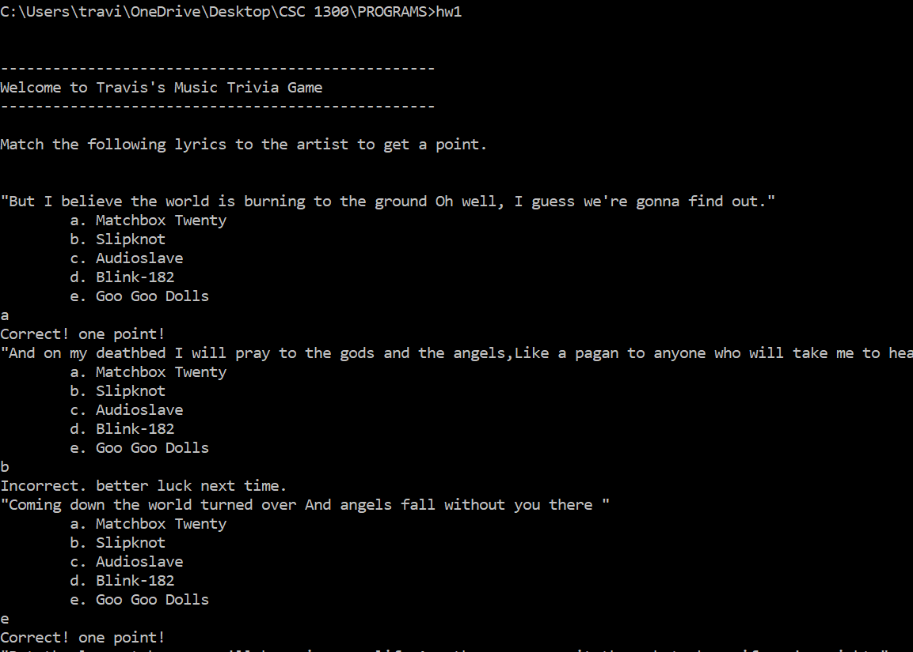

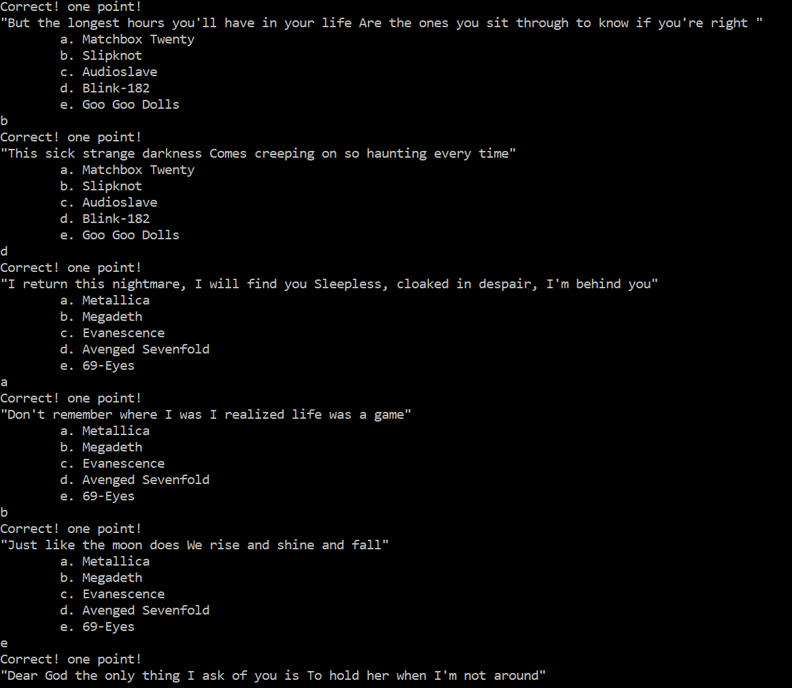

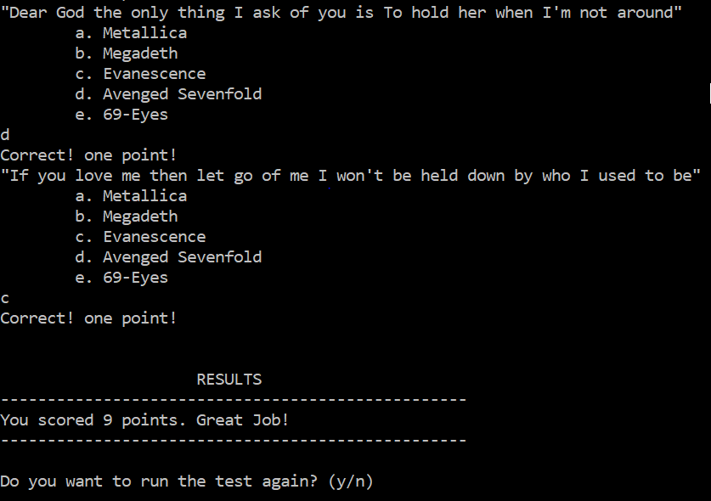

**Partial example when user gets a perfect score:**

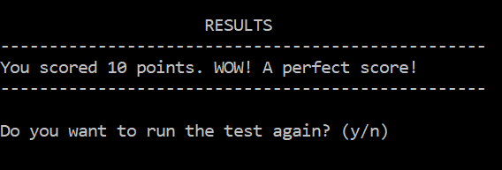

**Partial example with under 5 points**

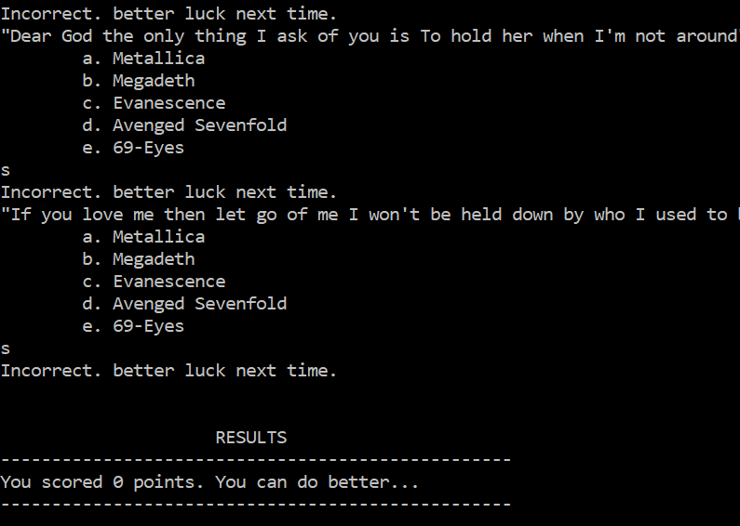

**Partial example where user plays again**

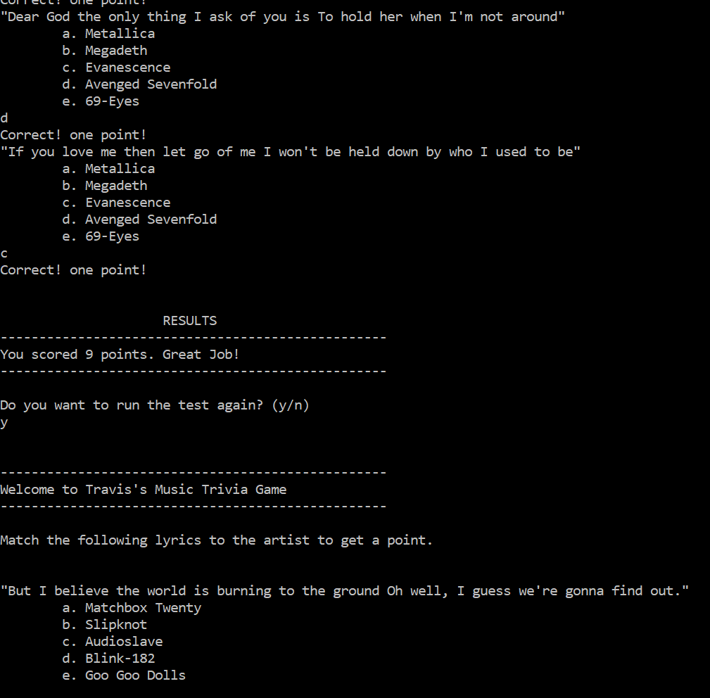

|  |  |  |  |
| --- | --- | --- | --- |
| **Programming Assignment # 1**  **Trivia Night** | | | **NAME:** |
| **Earned Points** | **Possible Points** | **Description Summary** | **Detailed Description** |
|  | **20** | **Compiles / Syntax Errors** | |
|  |  | **20** | Compiles with no errors – 20 points  Does not compile, but only has a very small error like missing one semi-colon – 15 points  Does not compile – 0 points |
|  | **60** | **Follows Program Algorithm & Specifications** | |
|  |  | **5** | Program will run as many times as user wants it to run. |
|  |  | **5** | Output is neat – easy to read - and spelled correctly. |
|  |  | **5** | Wrote ten ORIGINAL questions (did not copy mine) |
|  |  | **5** | Defined all variables with correct data type before using them & initialized them correctly. |
|  |  | **10** | Came up with three to five answers for ten questions and each answer will result in adding appropriate rank integer to a personality trait. |
|  |  | **30** | The results of the game are printed out to the user as specified in the program assignment. Should be very easy to read and correct based on student-assigned correct answers. Should display a different message depending on a perfect score, a score greater than or equal to 5 and a score that is below. |
|  | **20** | **Readability of Code** | |
|  |  | **4** | Comment block at top containing title of program, date, author, and purpose of program. |
|  |  | **7** | Sufficient comments in code. Comments should also be spelled correctly. |
|  |  | **7** | Code is indented properly (either a tab or 3-4 spaces, but must be consistent throughout program). |
|  |  | **2** | Variable names are appropriate for the data they are holding. |
|  | **100** | **TOTAL (FINAL) GRADE** | |